Post Upgrade Customization Deployment
Schindler CRD Applications

Exported on 2025-08-19 06:13:23

Table of Contents

No table of contents entries found.

- Article Referred: Article - CS446313 - How to run the com.ptc.core.lwc.server.EnumeratedTypeCustomizationMigrator utility in Windchill PDMLink
Migrate custom RB file entries to Modeled Enumerations
- Take backup of all OOTB modified Modelled enumeration
- Create ExportModeledEnum.xml with below content. (File is available in attachment)
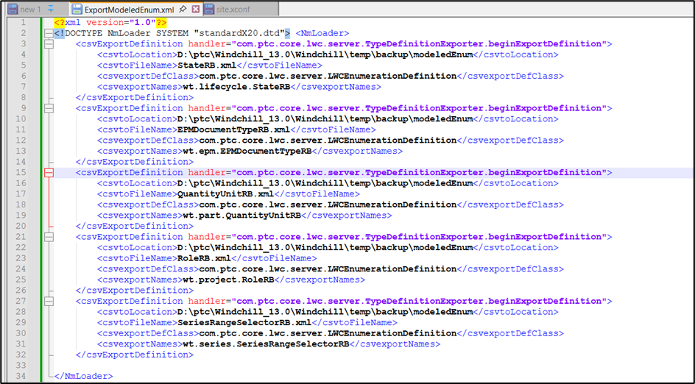

3. Run below command in windchill Shell
windchill wt.load.LoadFromFile -d D:\ptc\Windchill_13.0\Windchill\temp\backup\modeledEnum\ExportModeledEnum.xml -u wtadmin -p <password>
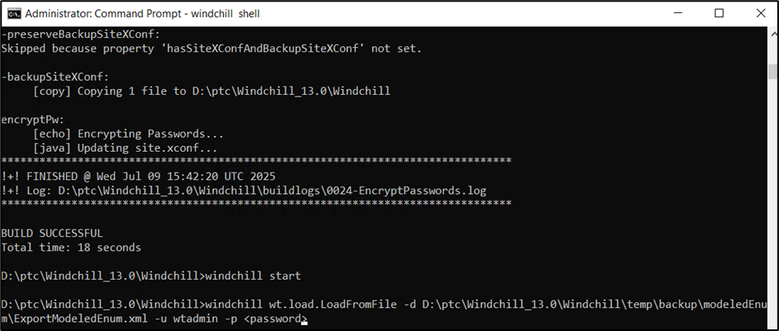
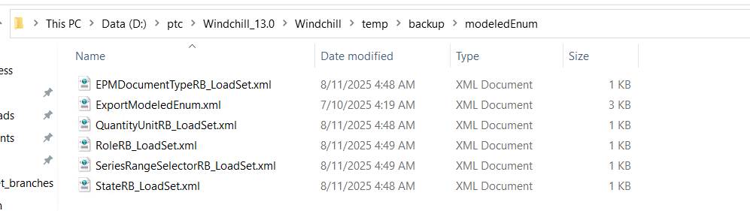
4. Copy wtCustom package from D:\BitBucket_branches in <WC_HOME> directory
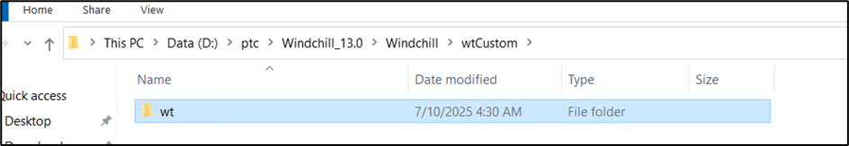

5. Run below command from windchill shell to migrate custom rbinfo files entries
windchill com.ptc.core.lwc.server.EnumeratedTypeCustomizationMigrator -u <userName> -p <password>
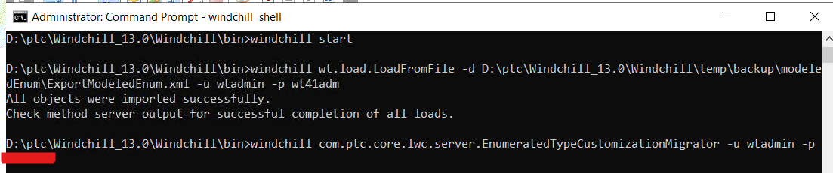

6. Enter wtadmin credentials
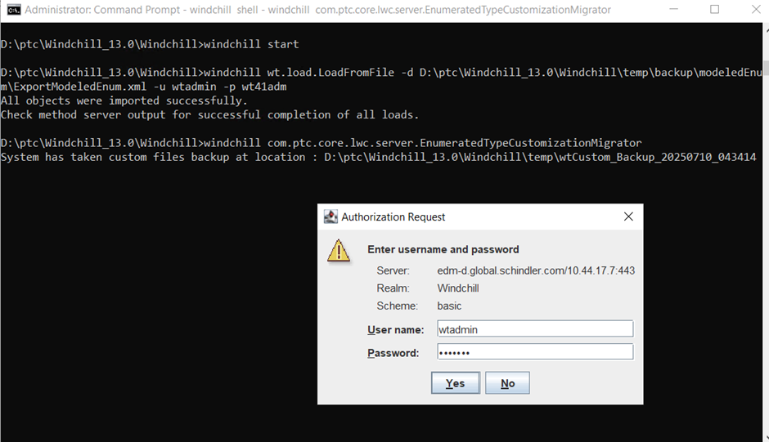
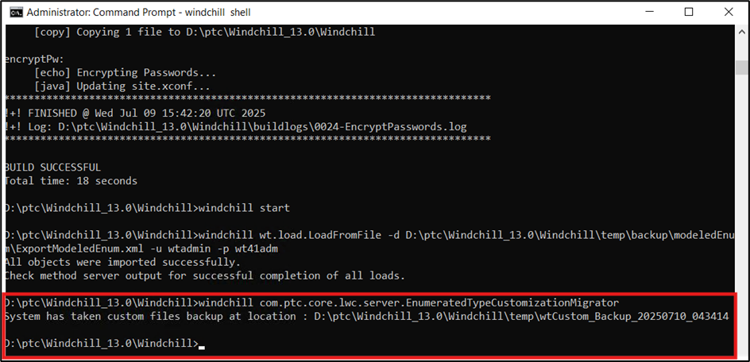

7. Validate there are no error reported in logs
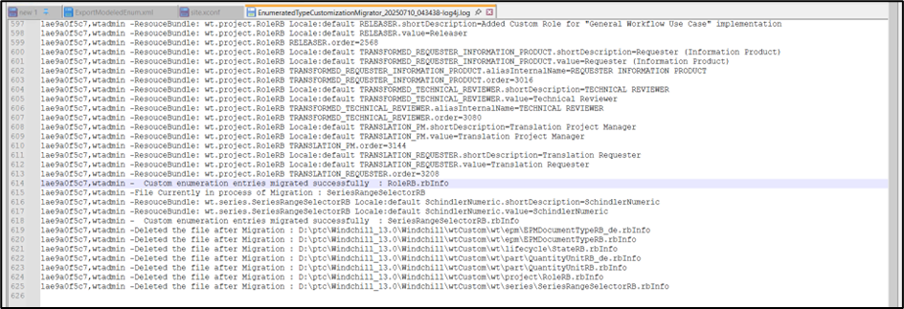

8. Navigate to Site > Utilities > Type and Attribute Management > Customize Modelled Enumeration and Validate the custom entries
